|  |  |
| --- | --- |
|  | **FPT ACADEMY INTERNATIONAL**  **FPT – APTECH COMPUTER EDUCATION** |

Lady’s Haven Shop

Instructor: Le Mong Thuy

Batch: T1-1810-E0

Team: Group 5

Student:

|  |  |  |
| --- | --- | --- |
| No | Full name | ID |
| 1 | Mai Anh Vu | Student1151441 |
| 2 | Van Tran Chi | Student1148303 |
| 3 | Nguyen Dinh Thai An | Student1151446 |
| 4 | Pham Minh Quang |  |

# Start date: 12/08/2019

**End Date: 17/09/2019**

**This is to certify that**

**Mr./Ms.:**

Mai Anh Vu

Nguyen Dinh Thai An

Nguyen Minh Thu

Pham Minh Quang

**has successfully designed & developed**

Lady’s Haven online shop

**Submitted by:**

**Mai Anh Vu**

**Date of issue: 12-Aug-2019**

**Authorised Signature:**

**Acknowledgement**

We would like to thank all the team member who has been working hard on completing this project. Special thanks to the team at the faculty for extending their support when we need. A special thanks to Ms. Le Mong Thuy for dedicating herself to helping us completing the project in a professional way.

Finally we would like to thank Aptech for giving us the opportunity to take part in the project so that we know what a project looks like when it comes to real world work project.

Table of Contents

**Part 1**5

Sypnosis5

Problem Statement5,6

Customer requirement7,8

Function flowchart of website8,9

Task sheet review 15

**Part 2**10

Page description 10

Site map11

Website mock chart12

Task sheet review 216

**Part 3**17

Mock of website full screenshot 17

Home17

Product17

Product specific18

Contact18

About us19

Sign up19

Sign in20

Task sheet review 321

**Sypnosis**

With the ever increase usage of internet throughout the globe, The needs to move to a new platform is heavily in need. In the old days, people would need to reach out to the authority and get their approval, then they have to look for business storefront that is beneficial when they open their shop. With the social media boom, the second step can totally be scrapped. We aren’t obliged to host our storefront physically anymore. Going digital is the trend and the cost that comes with it are much lower than before.

With that in mind, Lady’s Haven feels that they need to be more competitive within the field. A website with full functionalities is totally needed to drive the traffic and provide more convenience for the customers

**Problem Statement**

Lady’s Haven is an online store that sell various bags for both men and women. Now they need to revamp their website and add more functionalities to be up to current standard. The products are to be listed on the site. Consumers should find it easy to view various bags available with the store. The website must also contain details of locations, a feedback form and the map to the store.

With current standard, the website should be developed using HTML5, Javascript Geolocation and PHP. We will be also administering some famous framework into our site such as Bootstrap and JQuery. The site should work on all leading browser such as Google Chrome, Opera, Firefox, IE, etc.

What we will be looking at are:

**For the webmaster:**

* A central hub where they can control the privilege of the current admins. Either granting new accounts admin privilege, or revoking them.

**For the administrators:**

* When login with correct account, they’ll be granted access to the admin page with an admin dashboard, where they’ll be able to see the following features:
* A table containing the list of current users registered to the site.
* A tab menu on the left where they’ll be navigating the to many sub-pages.
* They’ll be also granted access to the product page, where the list of all current product will be present. They can also delete the product from the database, or add more products.
* They can see the feedback provided by customers account, as well as replying to said feedback.

**Customer’s Requirement Specification**

**Client:** FPT Aptech

**Project Objective:**

* To rebuild the shop’s website and add functionalities that fit the modern standard (online shopping cart, ordering, managing feedbacks, etc.)
* Revamping the site to be more attractive and easier to look at.

**Site’s Specification:**

* The Home page must have suitable logo and appropriate header (should have images of bags).
* The Home page body will contains information about the store and how the store does business, how long the store has been running and what the store will bring to the customer.
* The site must contain links to navigate through various types of bags, Backpack, etc.
* Site should have different section for men and women, and the bags should be placed accordingly.
* Links of bags should be categorized (backpacks, women’s bag, brand name, etc.)
* Specifications and pricing of bags should be added along with the image.
* There should be section for brand name in the store.
* Feedback must be allowed to be input by the user.
* Site map, Gallery, about us, Queries link, Contact us link must be added. Show the location using maps or GeoLocation API.
* The site should be able to be downloaded as pdf or doc file.
* Advertise section with various facilities provided should be included.
* There will be an about us section at the bottom of every page, included in a way that won’t hamper user experience.

Input to the system:

From webmaster:

* The webmaster must provide a full menu along with pictures and description for the products to admins.
* Select a couple of proper admin accounts and give them to suitable users so they can manage the site.

From visitor:

* Create account with their personal information (optional).
* Select food items to order.
* Provide their home address if they wish to be delivered to.
* Give ratings and feedbacks to the website as much as possible so they can improve the site functionalities and visualities.

Output from the system:

**For the visitor:**

* Information about Lady’s Haven.
* Search results.
* Form for sign ups, log ins and feedbacks.
* Website update from the webmaster and admin when there’s one.
* Account management page where they can alter the details if they wish to.
* Ordering and checkout page.

**For the admins:**

* Display information related to the current database that are connected to the website (Accounts database, product database, order database, feedbacks, etc.)
* Display the function for manipulating aforementioned database such as deleting or adding.
* For webmaster login, they will have a list of registered admin accounts where they can revoke or add more.

Hardware requirement:

* Pentium 166Mhz cpu or better.
* 64Mb or RAM or better.

Software requirement:

* Notepad/HTML Editor.
* Dreamweaver.
* IE 5.0/Netscape 6.0

Overall structure of the system:

The websites will be connected to a central server database, where we will store all user’s information (feedback form, registration info, etc.). Visitors can make request to access the details of many our products.

**Function Flowchart of the Web Sites**

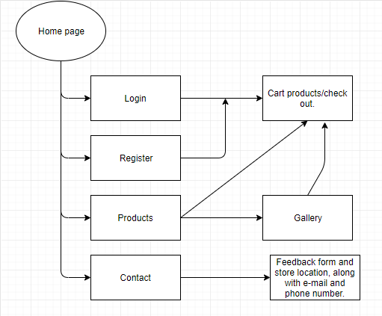

**Description:**

* Home page: Home page will contains information about the store, how we promote our business and how we treat our customer.
* Login: The user can login with the existed credentials, or create new one through Register page. By logging in, they will have the ability to save their products to the cart should they want to buy it at a later time, as products will be saved to the server.
* Products: This will be a showcase for various products, with options for filtering through categories of bags like: Men’s bags, Women’s bag, Brand name, etc.
* About us page: This will contain team member name, to show a little background about the team member behind the page.
* Contact: This page will contain information for the user to enter such as feedback form. The form will be sent back to the server and the host can revise the user experience based on the feedbacks. Map will also be provided, should the user wish to navigate to the storefront. Shop’s e-mail and phone number will be included as well. Within Contact there will be feedback form for customer to fill in.

**TASK SHEET REVIEW 1**

|  |  |  |  |  |
| --- | --- | --- | --- | --- |
| **No.** | **Description** | **Begin Date** | **Team mate Name** | **Notes** |
| 1 | Problem Statement | 18/02/2019 | Vu |  |
| 2 | Requirement Specification of BagBagonline.com Website. | An |  |
| 3 | DataFlow diagram | An |  |
| 4 | Function Diagram of Visitor | Chi |  |
| 5 | Task Sheet | Vu |  |
|  |  |  |  |
|  |  |  |  |
|  |  |  |  |

|  |  |
| --- | --- |
| **Date:** | |
| Signature of Instructor:  **LE MONG THUY** | Signature of Team Leader:  **MAI ANH VU** |

**II. Page Descriptions.**

* On the home page, is the information about the product of the product being sold to customers, including bags and handbags for both men and women.
* On the products page, the page contains image information about the product image, price, usage, preservation. Here, customers can directly purchase products on the website by clicking on the product.
  + Within the product page, we will categorize the bags into women, men and brand category. Inside the brand category, there will be sub-categories for different brands.
  + When clicking on a product, a page with more details of the product will pop up.
* Registration, login button is created for customers to register their information to the store. The store will store the information of the goods to understand the needs and characteristics of the customers, thereby serving the sale more conveniently.
* On the contact page, this page is used to acknowledge all customer comments about staff attitudes, quality of products. All that information will be sent to the owner. Let them know it, so that the webmaster can tweak the site to deliver better experience.

**III. Site Map.**

SITE MAP

Sigh Up / Log In Page

Sigh Up / Log In

Contact Page

Contact

Bags

Backpacks

Bags For Men

Product

Home Page

**IV. Website mock.**

Mock of the Website

1. Home page

Footer

Picture of the Product

Content

Header

(Logo – Navigation bar)

1. Product

Backpacks

Bags

Backpacks

Bags

**Bags for Women**

**Bags for Men**

Product Information

(Image, price and information)

Footer

Header

(Logo and Navigation bar)

1. Contact

Footer

Information about us

(Email – Contact number – Location – etc…)

Header

(Logo – Navigation bar)

1. Sign up/ Log in

Sign up Form

Login Form

Header

(Logo – Navigation bar)

Footer

**TASK SHEET REVIEW 2**

|  |  |  |  |  |
| --- | --- | --- | --- | --- |
| **No.** | **Description** | **Begin Date** | **TeamMate Name** | **Notes** |
| 1 | Indentify Entities | 20/01/2019 | Chi |  |
| 2 | ER Diagram | Chi |  |
| 3 | Properties of Entities | Vu |  |
| 4 | Design Table | An |  |
| 5 | Relationship Diagram | Vu |  |
| 6 | Structure of website content | Vu |  |
| 7 | Sitemap | An |  |
| 8 | Task Sheet | An |  |

|  |  |
| --- | --- |
| **Date:** | |
| Signature of Instructor:  **LE MONG THUY** | Signature of Team Leader:  **MAI ANH VU** |

**III. Mock website screenshot.**

1. **Homepage:**

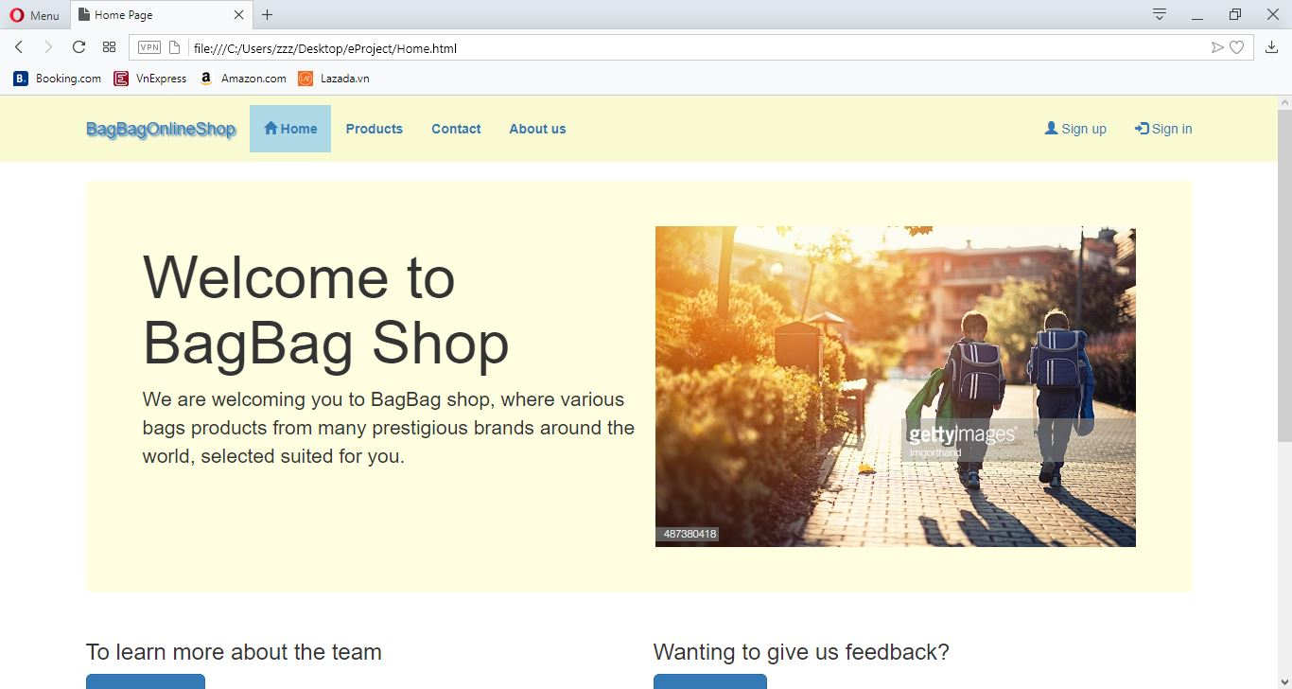

1. **Products:**

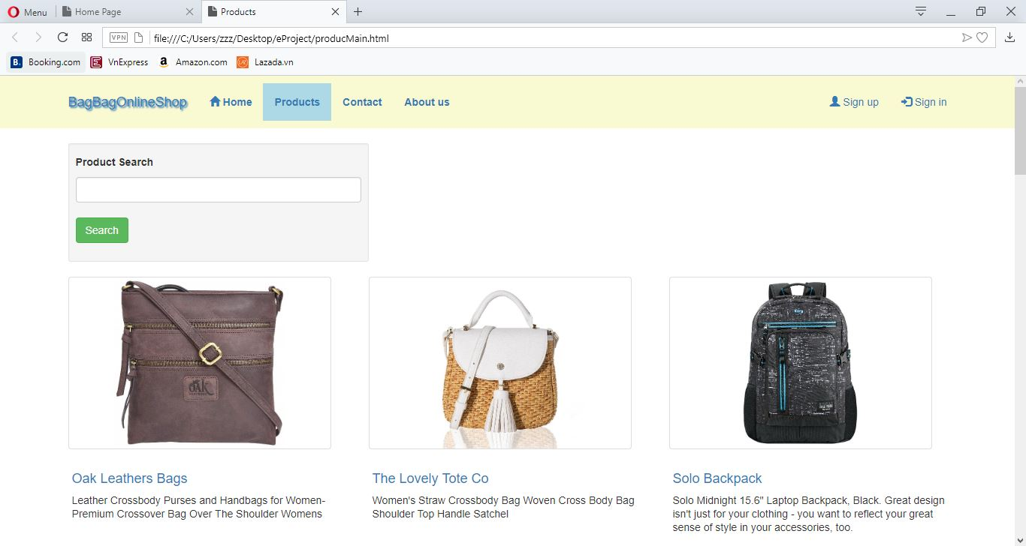

* 1. **Product specific:**

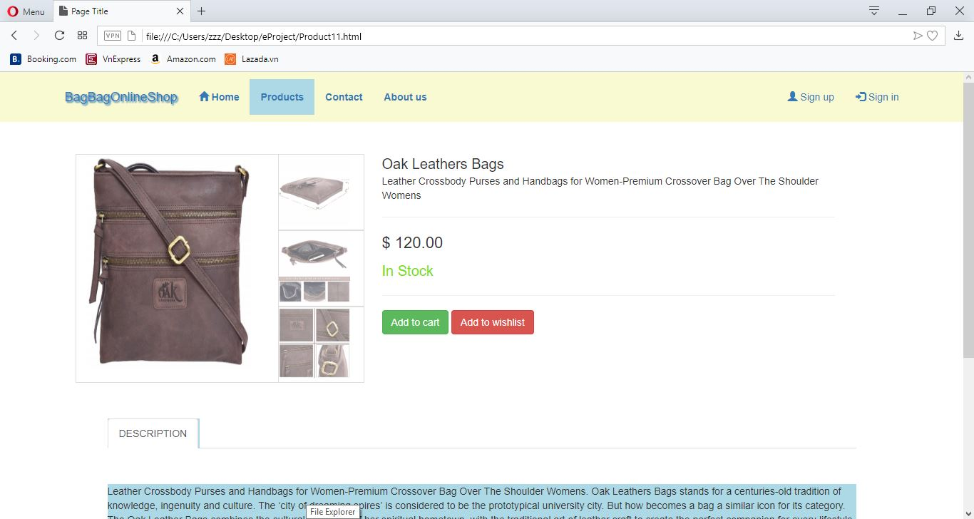

1. **Contact**

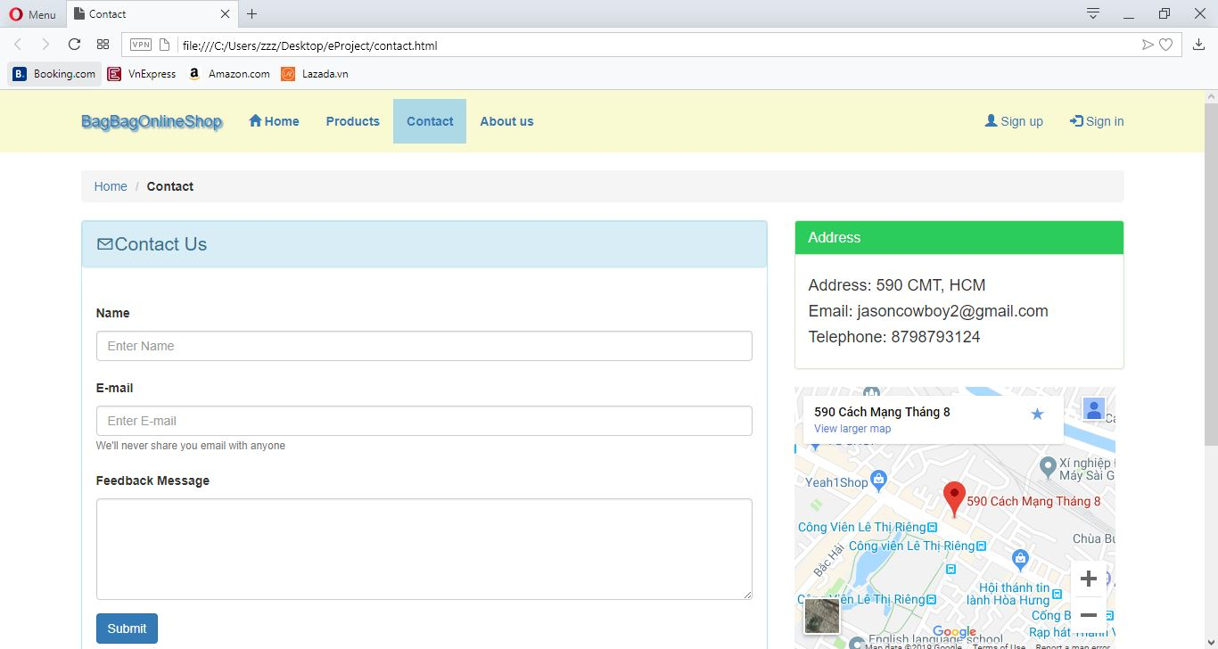

1. **About us**

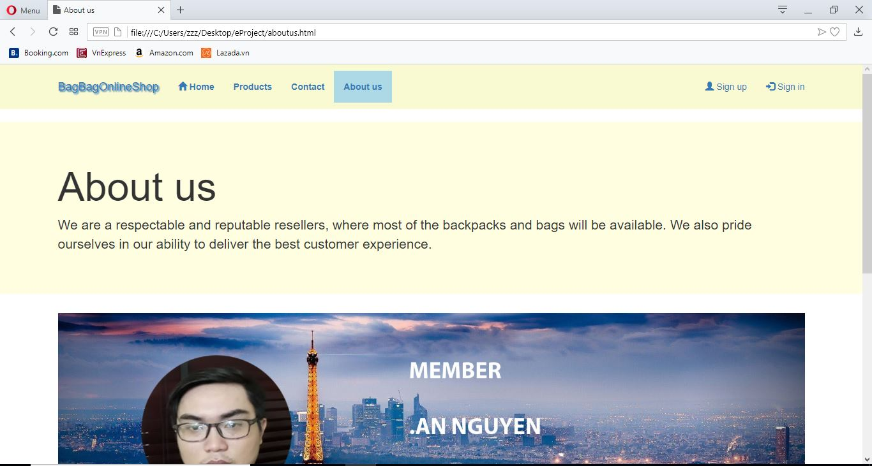

1. **Sign up**

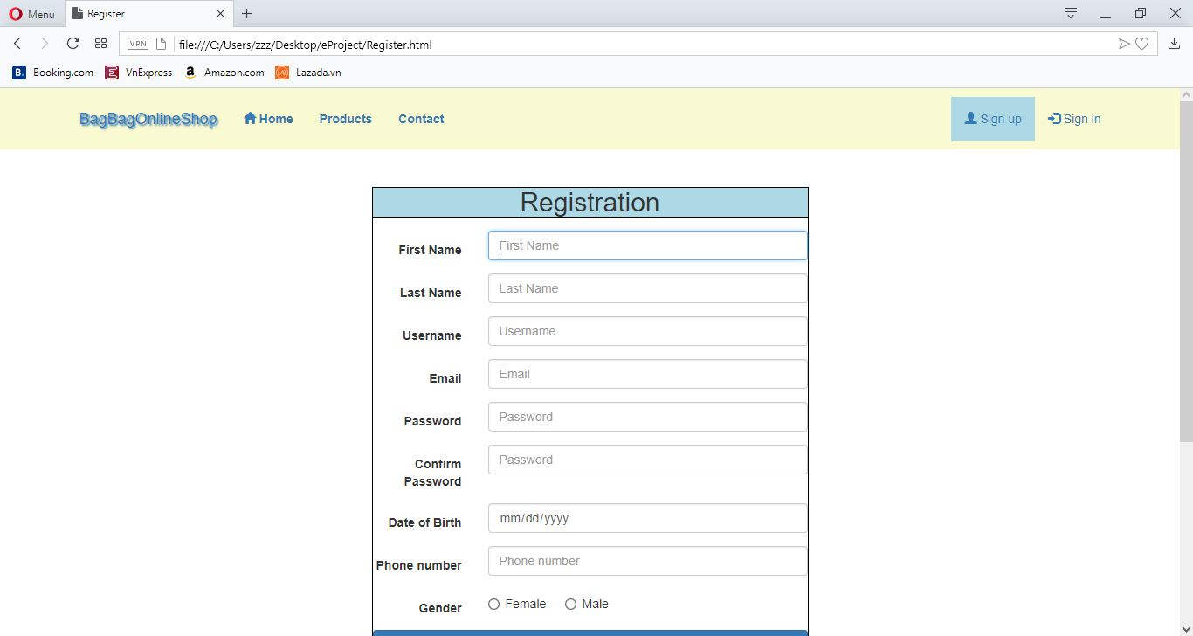

1. **Sign in**

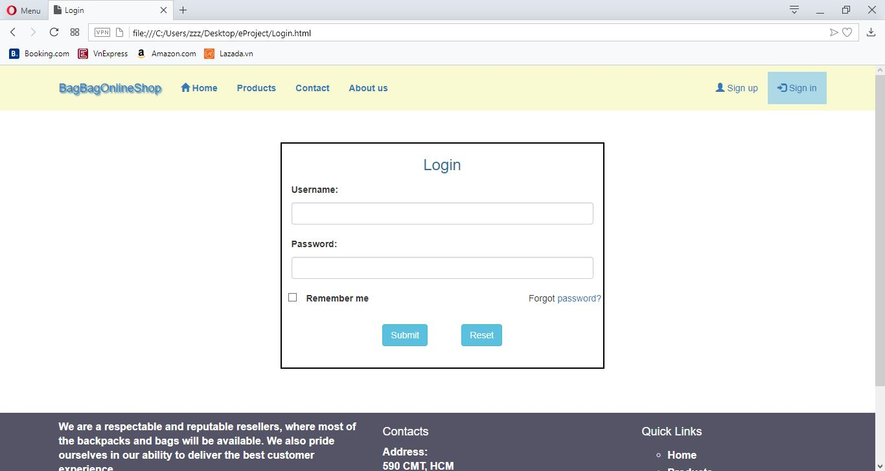

**TASK SHEET REVIEW 3**

|  |  |  |  |  |
| --- | --- | --- | --- | --- |
| **No.** | **Description** | **Begin Date** | **TeamMate Name** | **Notes** |
| 1 | Home | 15/2/2019 | Vu |  |
| 2 | Product | Vu |  |
| 3 | Contact us | Vu |  |
| 4 | About us | Vu |  |
| 5 | Sign up | An |  |
| 6 | Sign in | Chi |  |
| 7 | Product specific page | An |  |
| 8 | Task Sheet | Chi |  |

|  |  |
| --- | --- |
| **Date:** | |
| Signature of Instructor:  **LE MONG THUY** | Signature of Team Leader:  **MAI ANH VU** |